^{ONLINE PAYMENT FRAUD DETECTION}
MENTOR:SRI L.LAKSHMI NARAYANA
TEAMID:LTVIP2026TMIDS46417
3)YELETI SUDHARANI
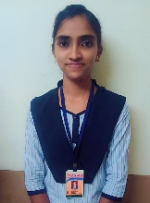Roll number:SBAP0040406 MAIL ID:yeletisudharani08@gmail.com
TSK:732084
Splitting data into train and test
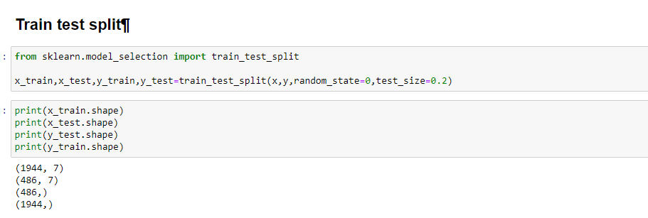
Model Building
Now our data is cleaned and it’s time to build the model. We can train our data on different algorithms. For this project we are applying four classification algorithms. The best model is saved based on its performance.
TSK:732085
Random Forest classifier
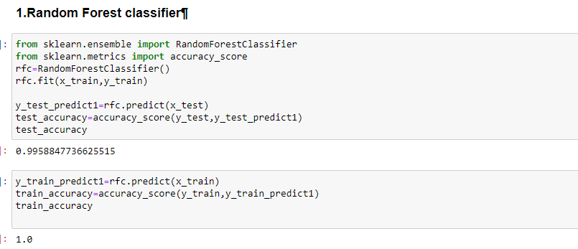

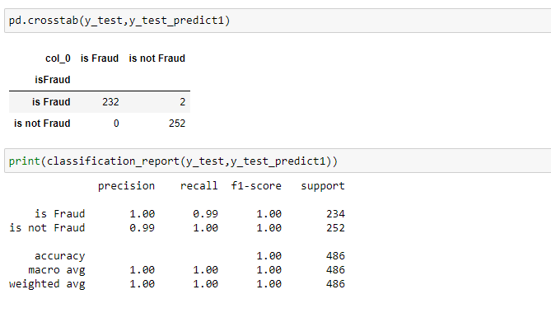
TSK:732086
Decision tree Classifier
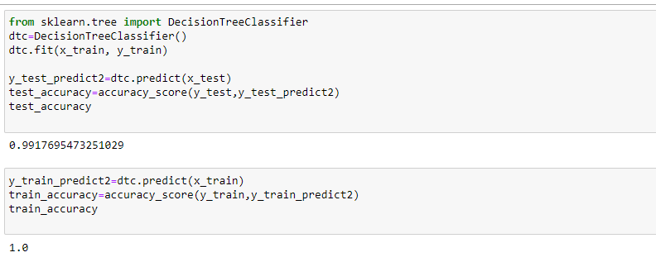
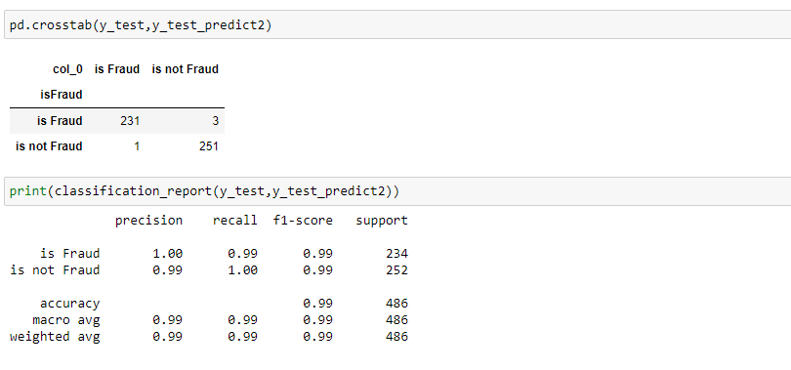
TSK:732091
Evaluating performance of the model and saving the model
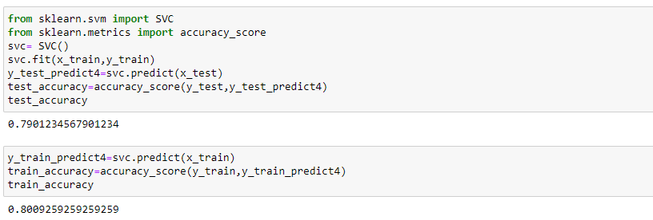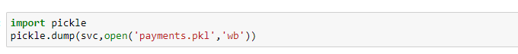
TSK:732092
Building Html Pages:
- home.html
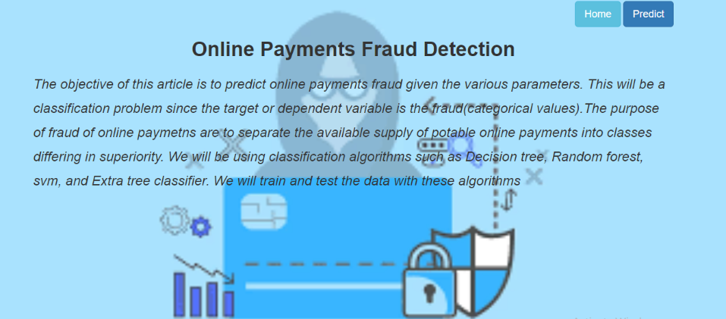
- predict.html
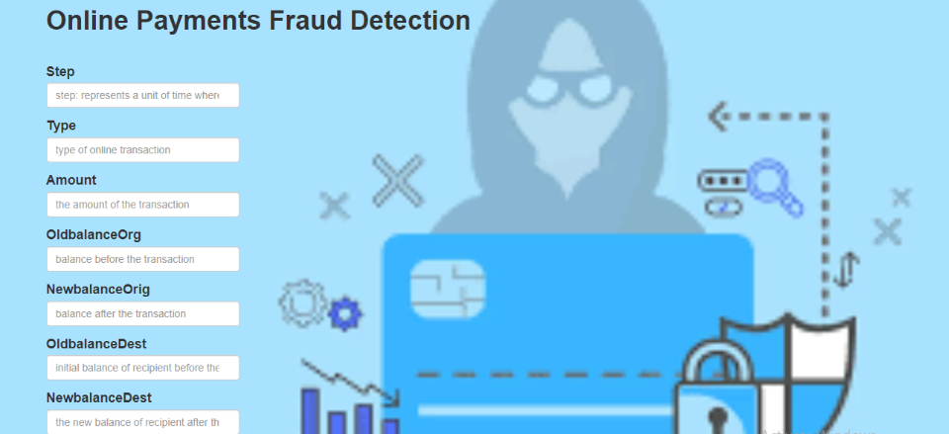
- submit.html
- 